**Creation of Angular Forms, Use of Materials & Services to design Front End**

**Angular Forms:-**

We have used angular forms in two components(Modules) Food Donation and Contact Us.

Our Basic Idea behind Food Donation Form is the user who wants to donate may be either money / food

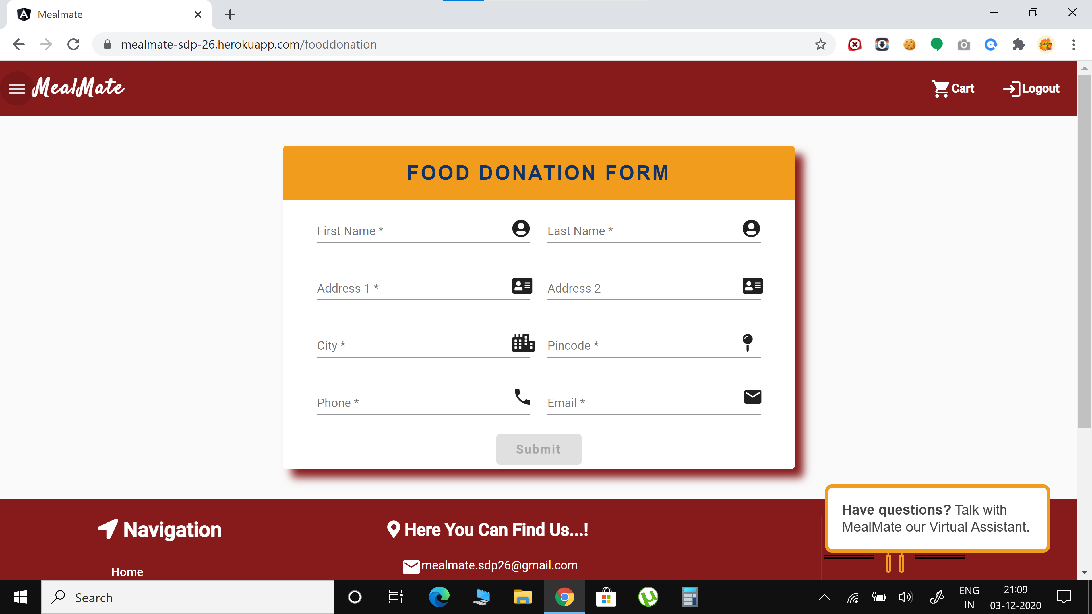

Contact Us form is Used to store the queries/feedbacks given by the customers

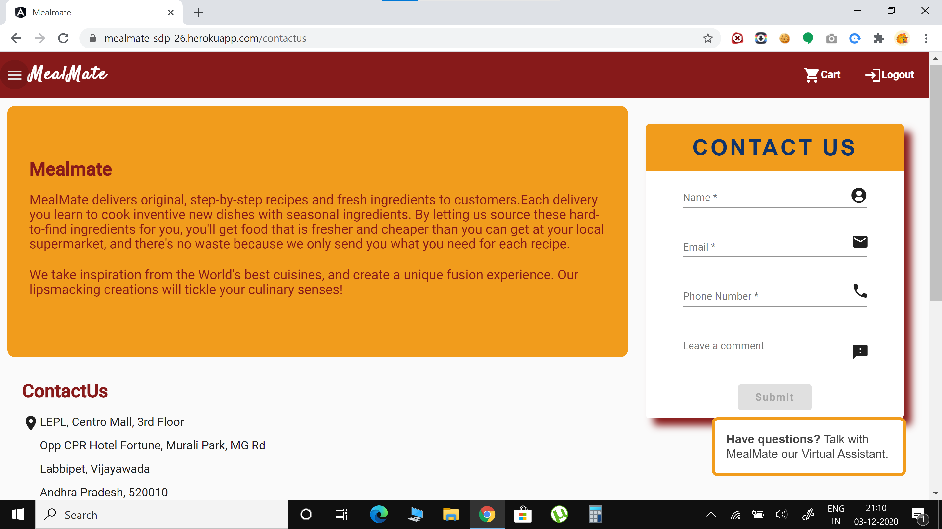

**Use of Materials & Services to design Front End**

Entire Front-end was developed using angular and angular material. The website is also responsive and tried hard to create a rich user Interface

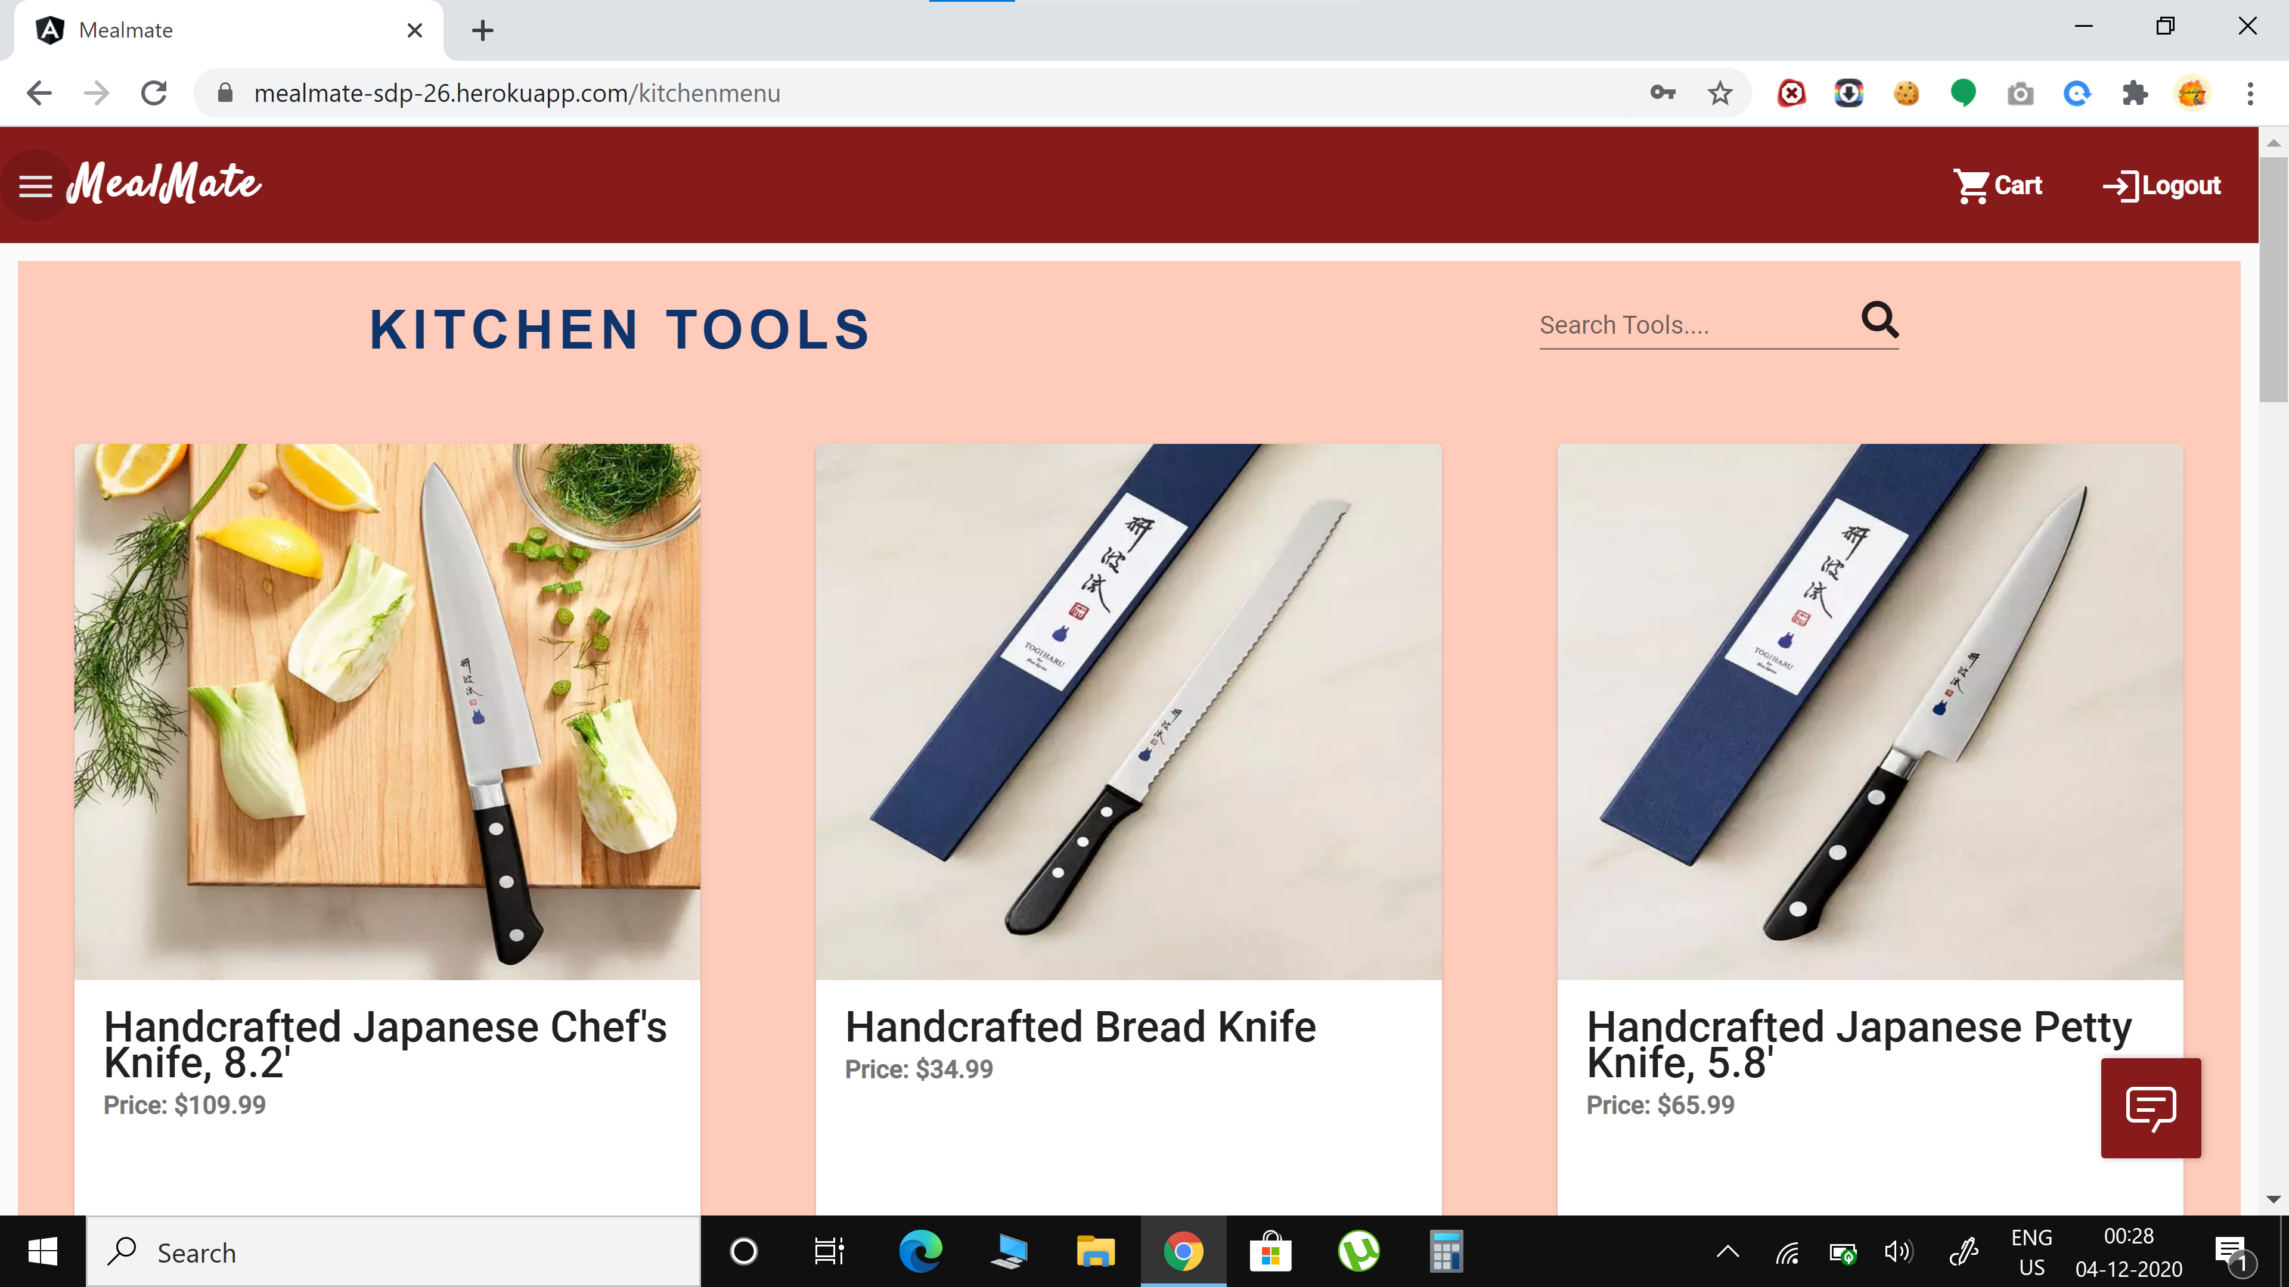

**Rich User Interface (Front end) including form validations**

As mentioned previously, entire Front-end was developed using angular and angular material. The website is also responsive and tried hard to create a rich user Interface

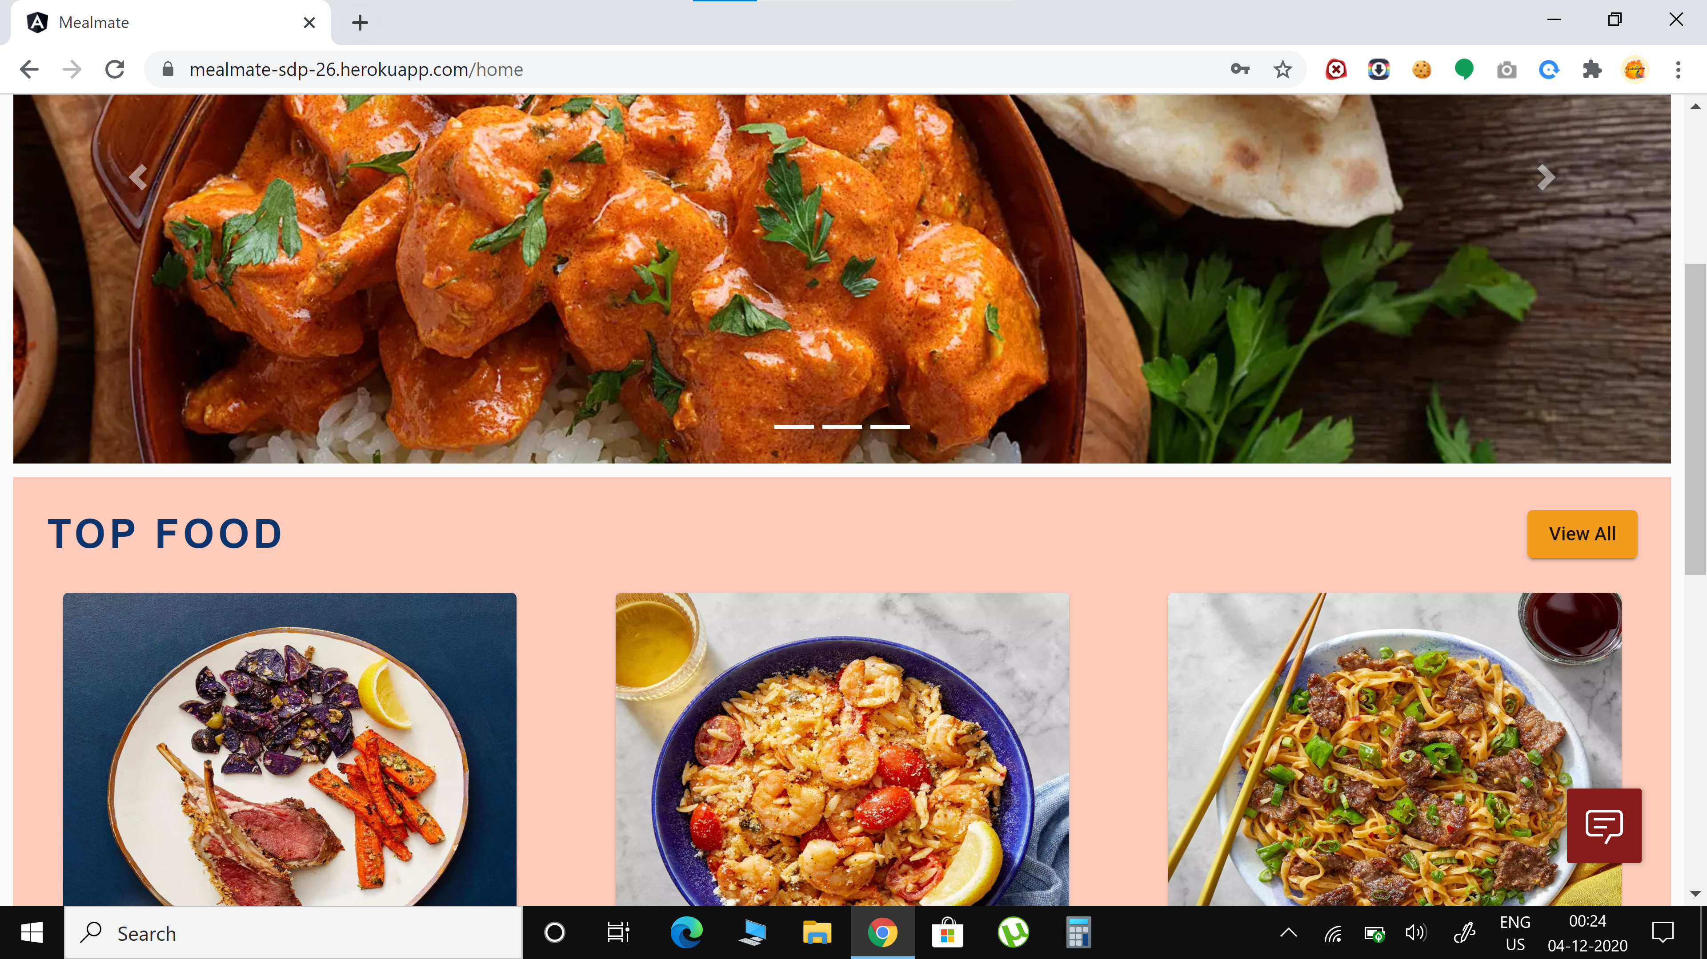

And Form Validations is also done perfectly based on the requirements(wherever needed)

One such example

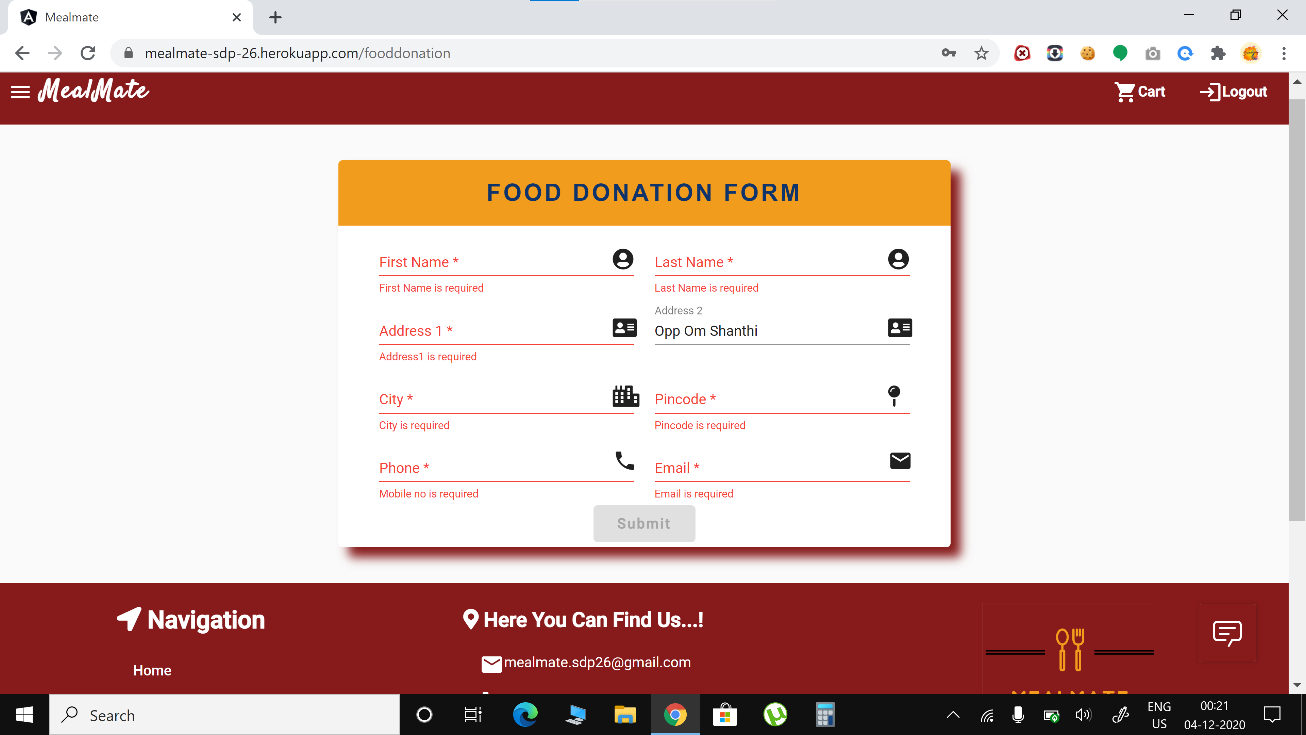

**Component based Angular Programming**

We have done the project using Component based Angular Programming only. We got 24 components in total.

Here is the picture as a proof. The files have been pushed to gitlab.

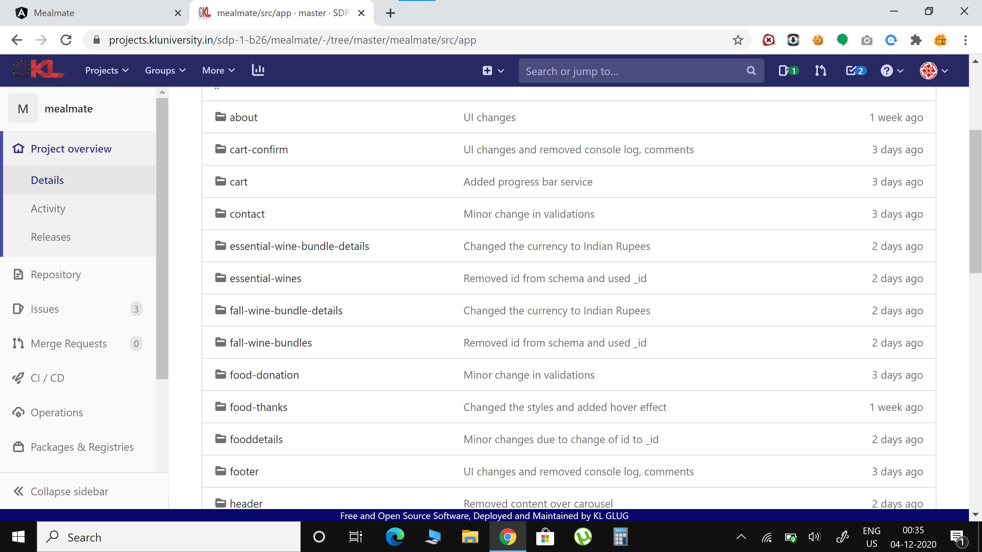

**Creation of webserver using Node.js**

Here the pic of Creation of webserver using Node.js along with successful execution in the terminal

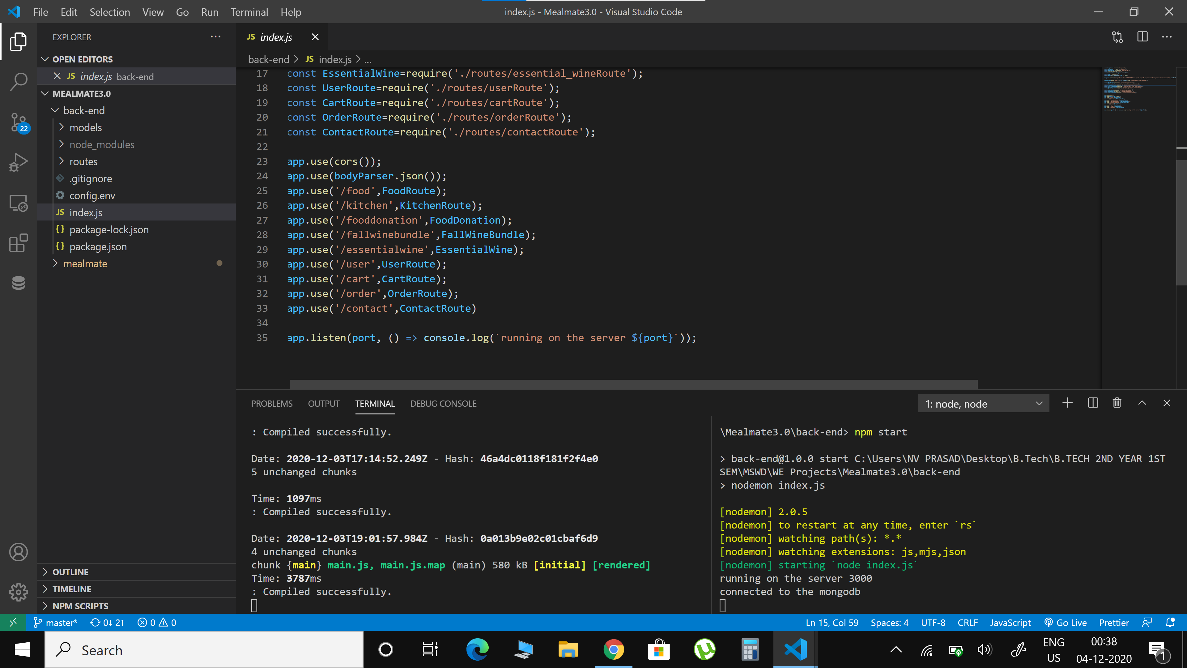

**Session Management**

The session management is done using json web tokens.

When the user logged in a token is generated and is valid till he logged in. After he logout the token is deleted.

Here is the pic of token stored in local storage.

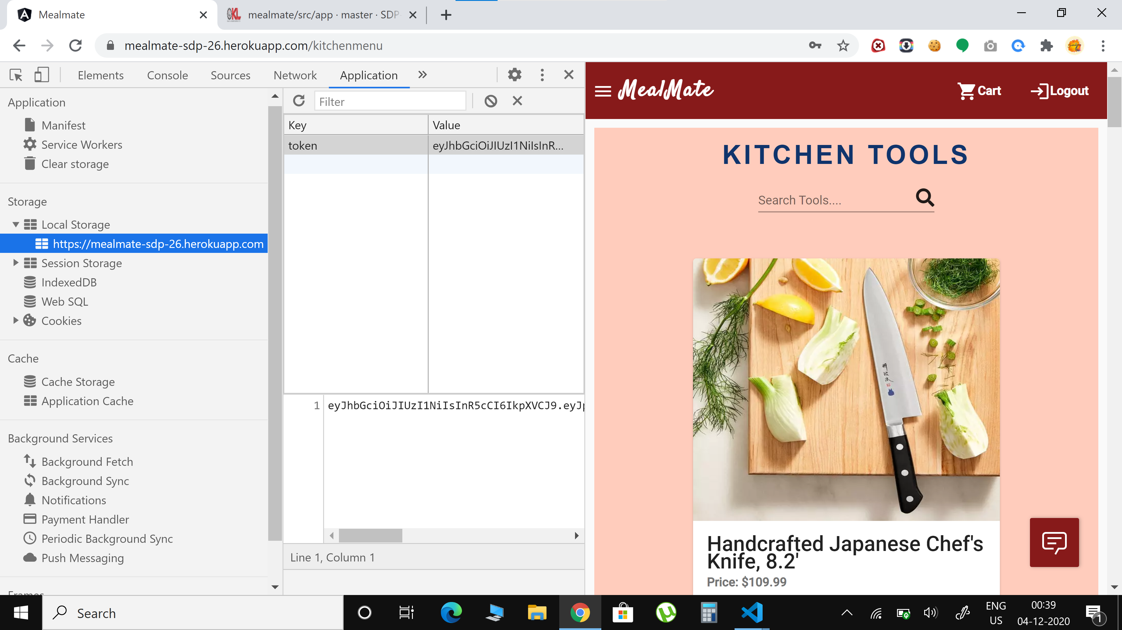

**Angular and MongoDB with Node.js interaction**

This is the code where we have successfully implemented Angular and MongoDB with Node.js interaction

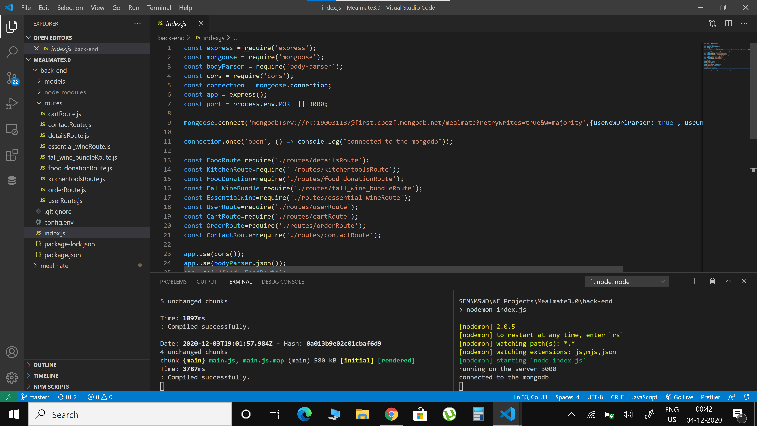

**CRUD Operations on Database as Back End**

We have implemented the all the crud operations

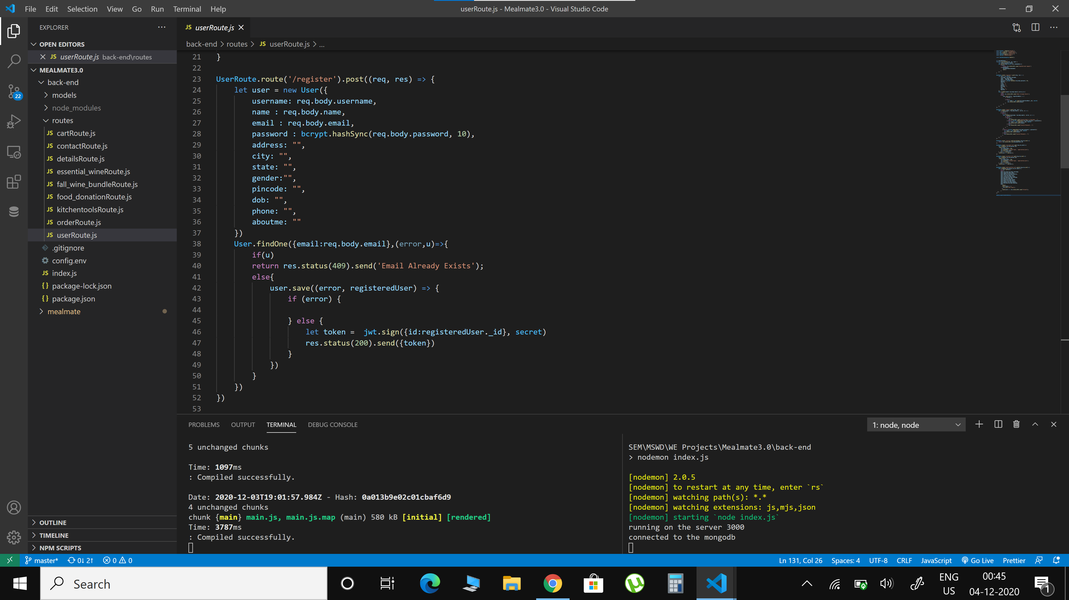

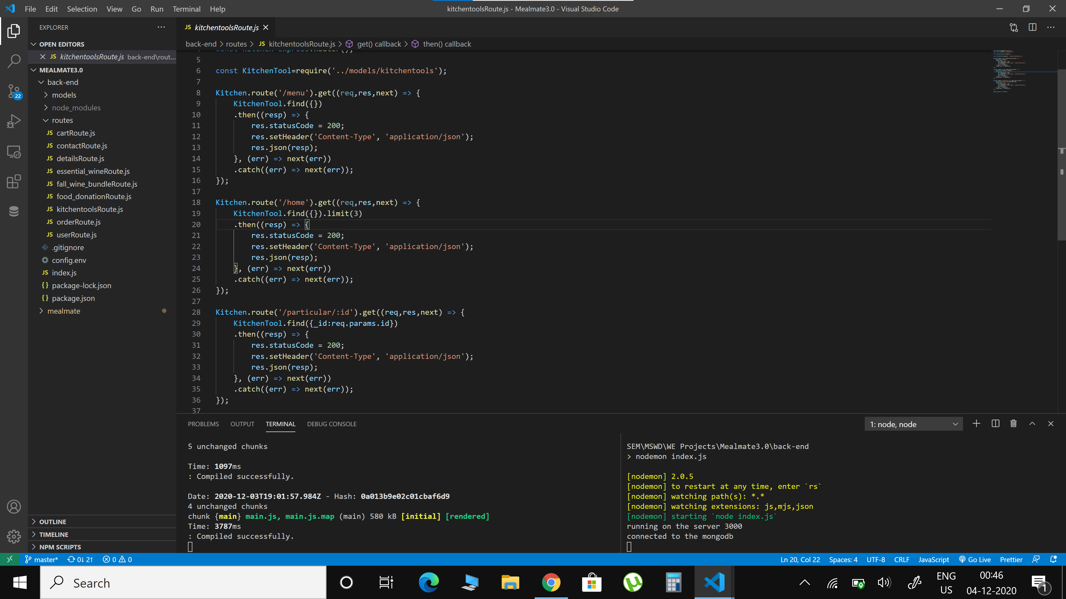

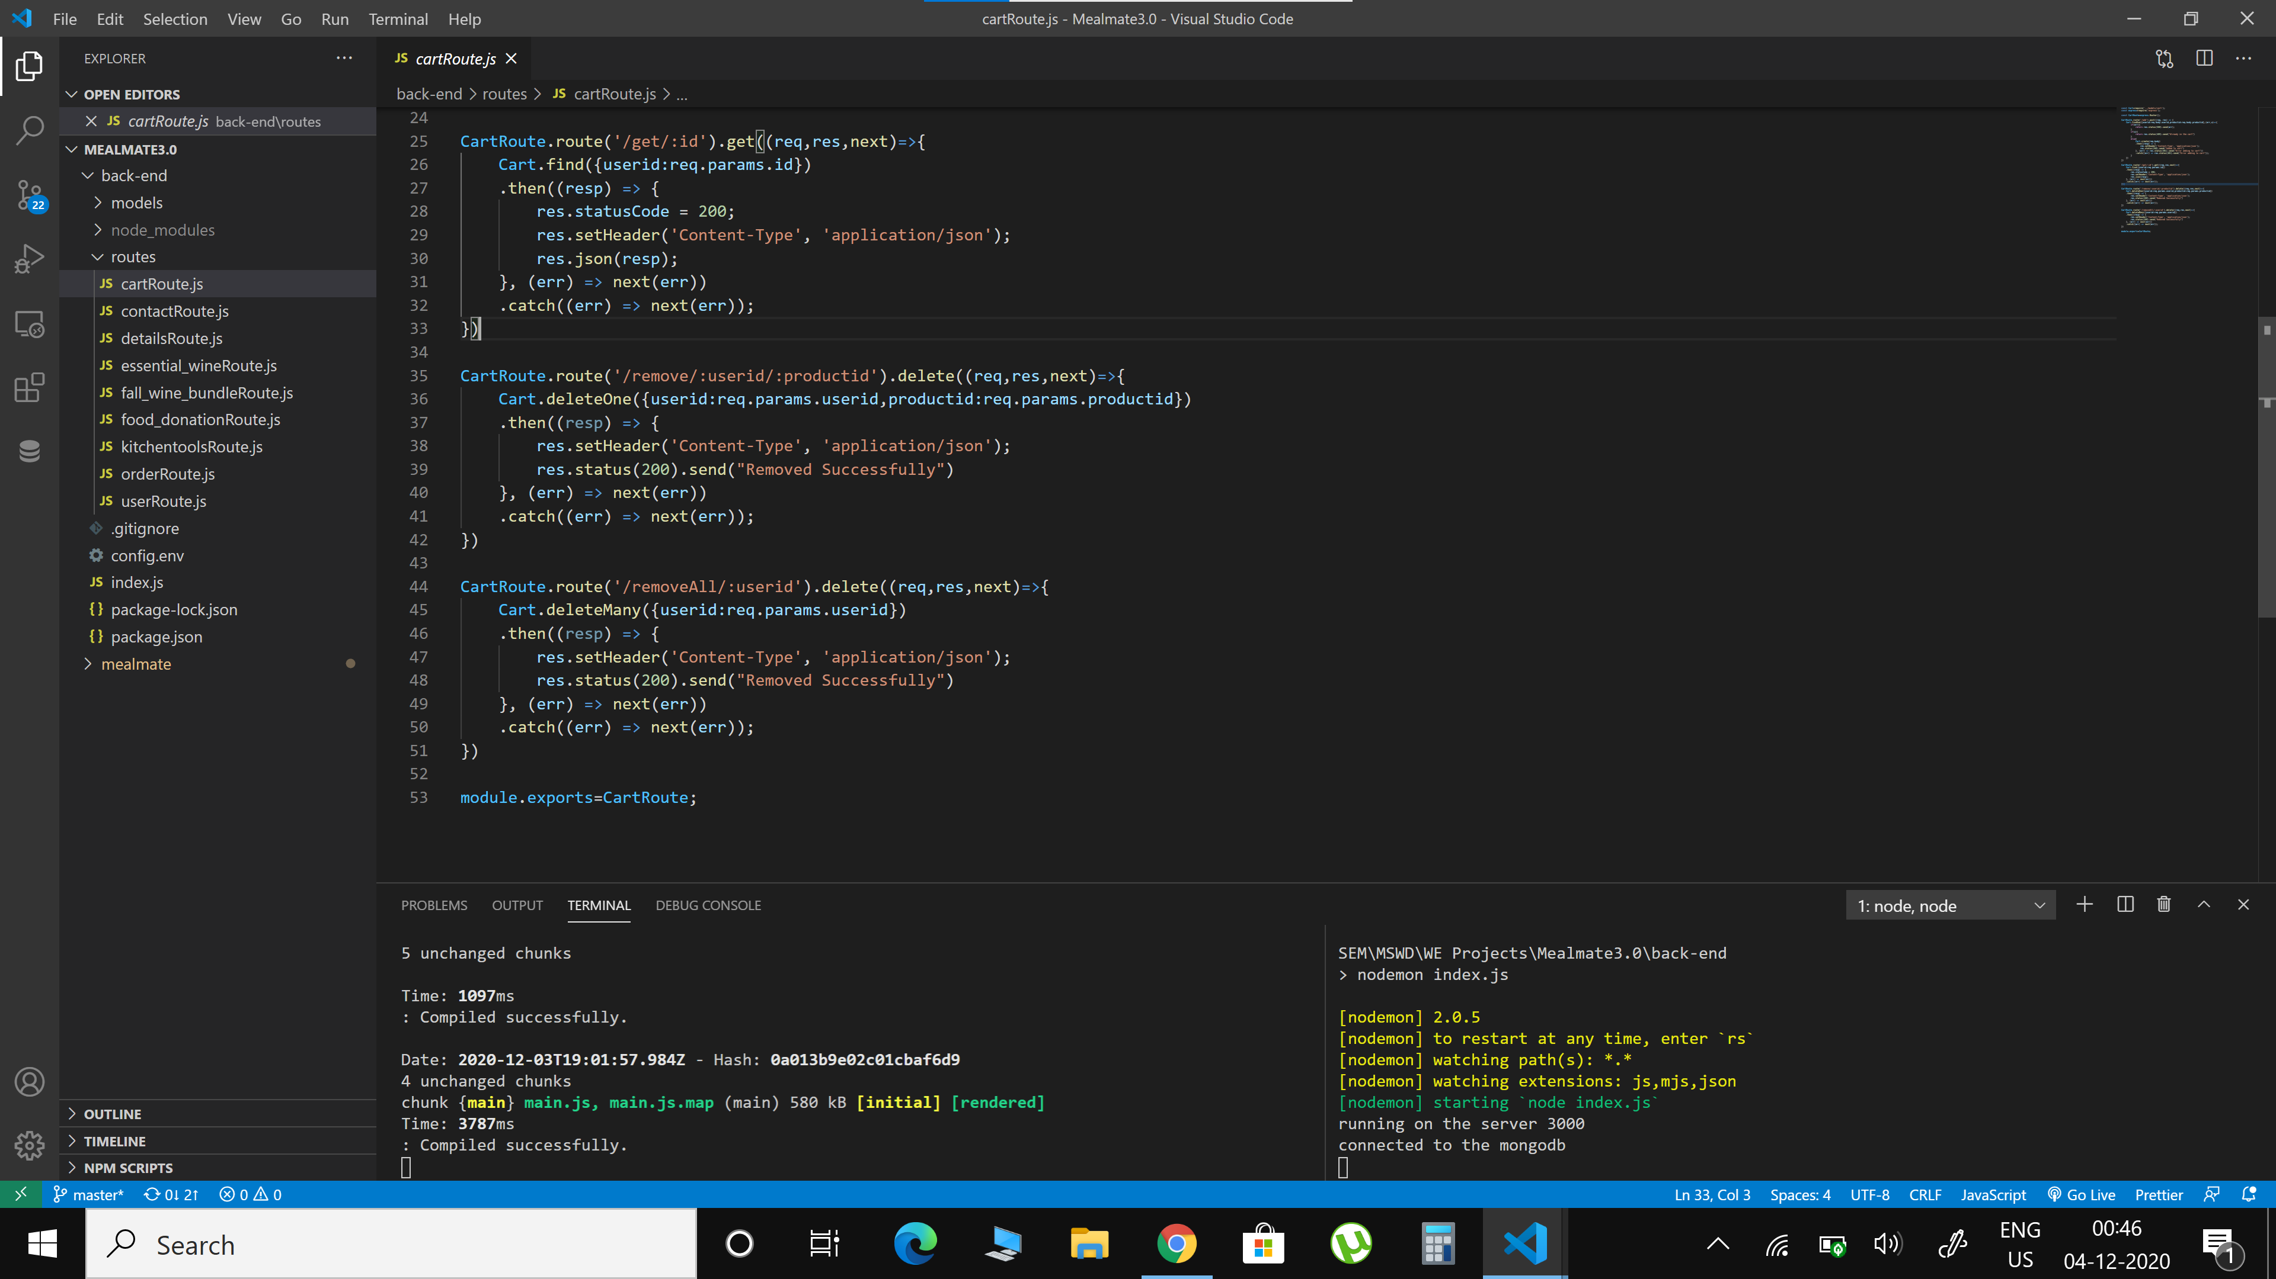

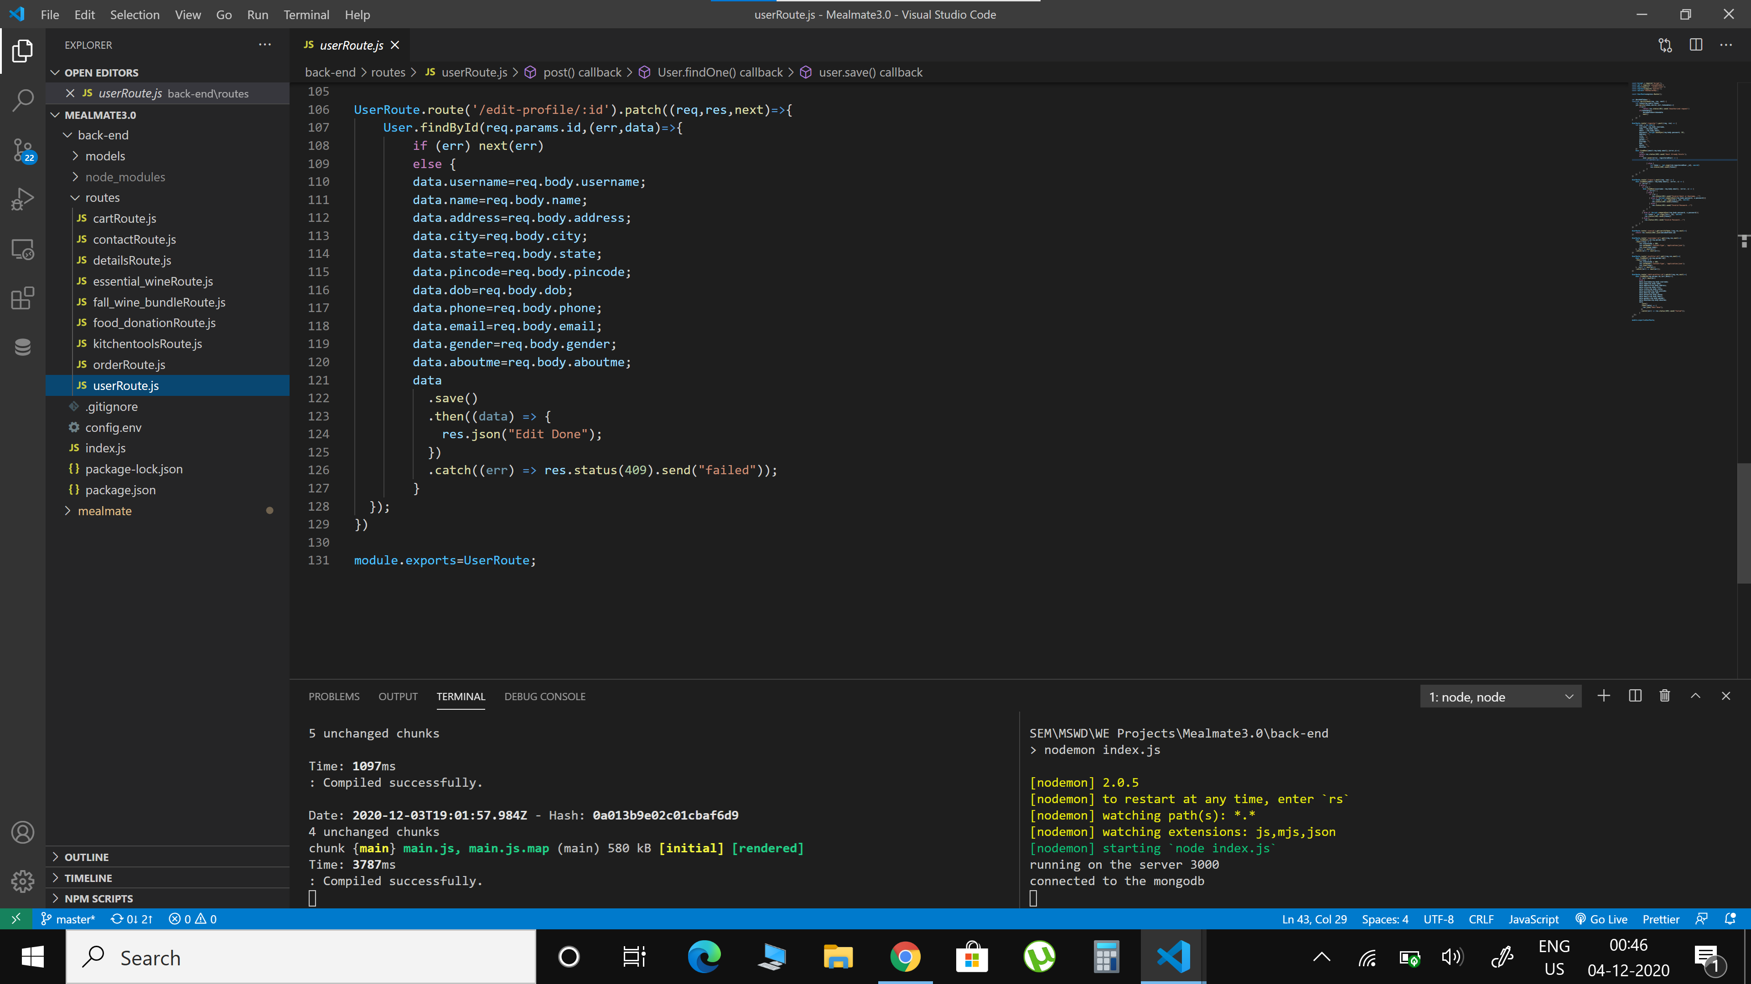

**Final output as per the client requirements**

We have successfully designed the website as per the client requirements

